Report on Merge Two Sorted Linked List (with head node)

**⚫ Vital information:**

U10P32002, School of Computer Science and Technology, NPU, Spring 2019

Written by Dikshya Kafle

2018380039

Programming Assignment 5 Due date: April 22

⚫ **Problem Statement**:

In this program we are supposed to create a program which takes number from two lists named m and n. We should first enter the length of each sorted lists and merge to find another sorted list. These two lists are two singly linked lists that are already sorted we are supposed to merge them and return the head of the new list without creating any new extra nodes and the returned list should be sorted as well.

⚫ Structure Chart:

main

Void list::merge(list,list)

Void list::build

Void list::display

**⚫ Implementation**

A linked list is made up of many nodes which are connected in nature. Every node is manly divided into two parts; one part holds the data and other part is connected to a different node. In the program we achieve this functionality by using structures and pointers. Each structure represents a node having some data and the address of the next node and creates the link between two nodes.

In the merge.cpp two list classes are created one is Private which is not written in the program because it automatically act private class when the public class is defined afterwards. The class contains all the functions and data members required for a linked list. The class used structure node of the creation of linked list. Node of a linked list is defined using the structure. Data field of the integer is being defined as int data; Similarly, pointer to store next node address is written as struct node *next.

The first data member of the structure in an integer to hold an integer and the second data member is the pointer to a node. This means that the second data member holds the address of the next node and this way every node is connected.

Public class contains three void functions:

Void build () and void display () are no return type whereas void merge (list,list) is a return type.

In **int main()** is where the program begins from. As asked in the recommended file I named two sorted linked list as n and m and the final merged sorted list is named as finalist in the program.

**void list::build():**

operators used:==,->,*,>>,<=,++

This subprogram uses one for loop to compare the data value. This process continues till it finds the Null value. Afterward, if else statement is being used in the process of comparing two sorted list.

**void list::display():**

The main function of this subprogram is to display the list. The two sorted list are to two sorted lists are to be displayed. This section include one while function to check the condition when the head list is not equal to null it is to carry on pointing the next node. This is how the list is formed.

**void list::Merge(list n, list m):**

This is the very important part of the program. While statement is used here to compare the two head lists and to find the sorted list. If the condition is null the program list is sorted already but in the case when the program is not sorted the next node is being pointed and after the comparison of sorted list the final merged sorted list is being created.

**⚫ Test Description and Results**:

At first I enter the length of the first sorted list n. As seen in the result below I entered the n value 5 and the numbers in the first sorted list are 1 4 9 10 11. As similar to that, the length of the second sorted list i.e. m is 4 and the numbers in the sorted list are 0 2 5 14. Finally after entering both sorted lists the final sorted list is being displayed one in each single line. The following is the result displayed after running the program:

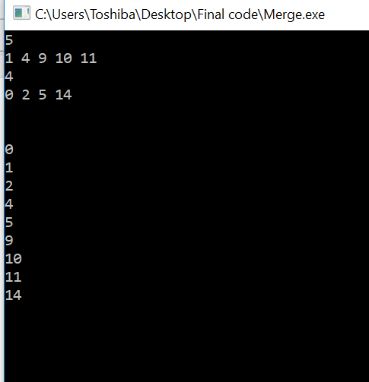

⚫ **Epilogue**:

While doing the program there was a lot of bugs. This was due to my incorrect form of syntax and might have been some logic error too. The huge bug was when I failed to merge the lists. As you can see in the below:

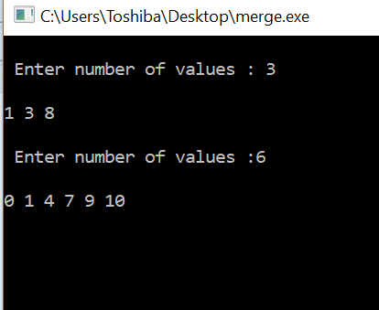

As displayed above I could run the program but it would not give the result which I was supposed to have. After doing a lot of research I came to figure out the error was in the if statement. My logic was not clear. However after figuring out the solutions it was a really great feeling. I felt a little stressed relieved. The very interesting part about the program was that the idea of merging two sorted linked list was itself very interesting. Now I understand what are singly linked list , what are sorted list and how the list are merged in C++. It’s a new achievement for me

**⚫ Attachments**: The file merge.cpp is attached in the email. This is the report of the file merge.cpp.

**⚫ Acknowledgement**: I got ideas from various coding websites and also watched a lot of YouTube videos relating merged linked list. I took notes which helped me figure out a lot of things while writing the program. However, I was not able to get the result as expected. It took a lot of research and later on I discussed about my problem with Amir the student in the same class. He explained me about my errors in the program. This is how I got to figure out the whole solution for the program.